SMOKE DETECTION USING MQ-2 GAS SENSOR

B Sujith - RA1611008010058

M Dilip - RA1611008010074

AIM:

To make an IOT Project for detecting Smoke in emergency conditions using MQ-2 gas sensor.

HARDWARE COMPONENTS:

Arduino UNO

Bread Boardx vbn

MQ-2 Gas Sensor

Jumper Wires

5mm LED - RED

5mm LED - GREEN

Buzzer

Resister 221 ohm

SOFTWARE COMPONENTS:

Arduino IDE

CONNECTION DIAGRAM:

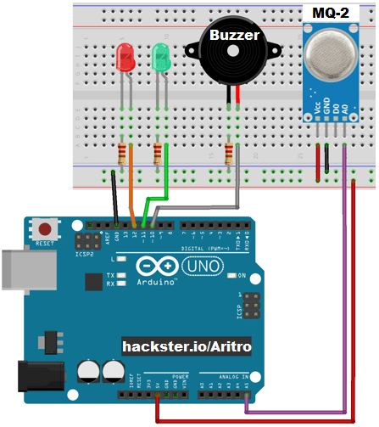

Procedure:

Step1:

Components required

Arduino UNO

Bread Boardx vbn

MQ-2 Gas Sensor

Jumper Wires

5mm LED - RED

5mm LED - GREEN

Buzzer

Resister 221 ohm

Step2:

Connections

1. connect red led to pin 4 in arduino .
2. Connect green led to pin 3 in arduino.

3.Connections for mq2 sensor is like this:

Sensor VCC to pin 5v in arduino.

Sensor gnd to pin gnd in arduino.

Sensor D0 to pin 2 in arduino.

4.connect buzzer to pin 5 in arduino.

Step 3:

CODE:

int val = 0;

void setup()

{

pinMode(2, INPUT);/sensor input

pinMode(3, OUTPUT);/green led

pinMode(4, OUTPUT);/red led

pinMode(5, OUTPUT);/buzzer

digitalWrite(3, HIGH);/green led high

digitalWrite(4, LOW);/red led low

digitalWrite(5, LOW);/buzzer low

Serial.begin(9600);

Serial.print("LOW");

delay(2000);

}

void loop()

{

val = digitalRead(2);

if(val==0)

{

digitalWrite(3,LOW );/green led low

digitalWrite(4, HIGH);/red led high

digitalWrite(5, HIGH);/buzzer high

Serial.print("HIGH");

delay(2000);

}

if(val==0)

{

digitalWrite(3, HIGH);/green led high

digitalWrite(4, LOW);/red led low

digitalWrite(5, LOW);/buzzer low

Serial.print("LOW");

}

}

Step4:

Upload code to arduino broad using arduino IDE software.

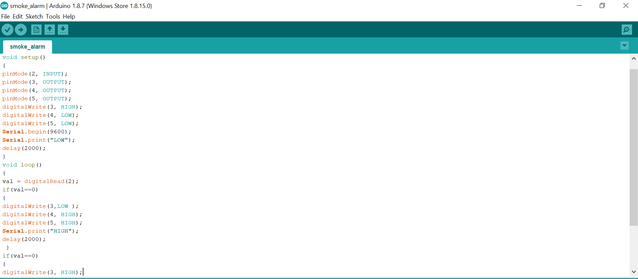



Conclusion:

Smoke detector is one of the easiest and low costly. Most of industries use it, Because it work fast to protect and effective. Cheapest and best with alerting people of the danger of a fire. Since the smoke detector was created many forms have been derived to accommodate all type of people.